Chapter 9, Solution 15.

- 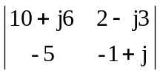 = -10 – j6 + j10 – 6 + 10 – j15
= –6 – j11

- 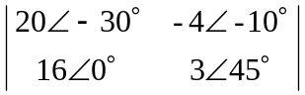 = 6015 + 64-10
= 57.96 + j15.529 + 63.03 – j11.114
= 120.99 + j4.415

- 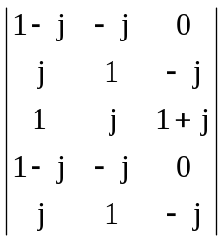
= (1–j)1(1+j) +j²0+1(–j)(–j) – 0(1) – (1–j)(–j)j – j(–j)(1+j)
= 2–1 – 1 + j – 1 – j = –1

